# Subsetting Columns

This document includes the question, the solution, and a breakdown of the code provided in the screenshot.

## Uploaded Screenshot

Below is the screenshot of the task:

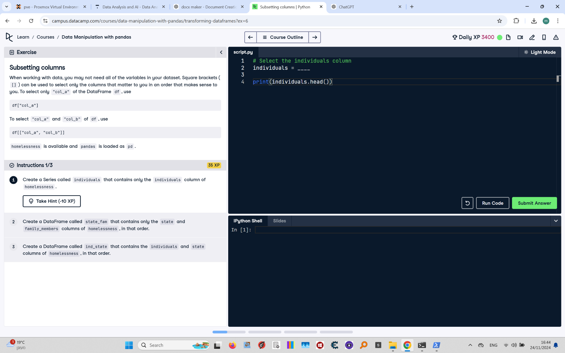

## Question

Create a Series called `individuals` that contains only the `individuals` column of homelessness. Print the first few rows of the Series.

## Answer

# Select the individuals column  
individuals = homelessness["individuals"]  
  
# Print the first few rows  
print(individuals.head())

## Code Explanation

# Explanation of the code:

1. `homelessness["individuals"]`: Selects the `individuals` column from the `homelessness` DataFrame. The result is a pandas Series.

2. `individuals`: Stores the resulting Series for further use.

3. `print(individuals.head())`: Displays the first five rows of the `individuals` Series to check its contents.